Case Study: Hospital Management System Monitoring with Dynatrace OneAgent
This case study is designed for hands-on practice with OneAgent, Smartscape, PurePath, services, processes, and dashboards in Dynatrace.
You can simulate this in a lab using:
- 1 Linux server (Application + DB)
- 1 Web server (Nginx/Apache)
- MySQL/PostgreSQL database
- Sample hospital web application (Node.js / .NET / Java – any stack)
1. Business Scenario
Organization: CityCare Multi-Speciality Hospital
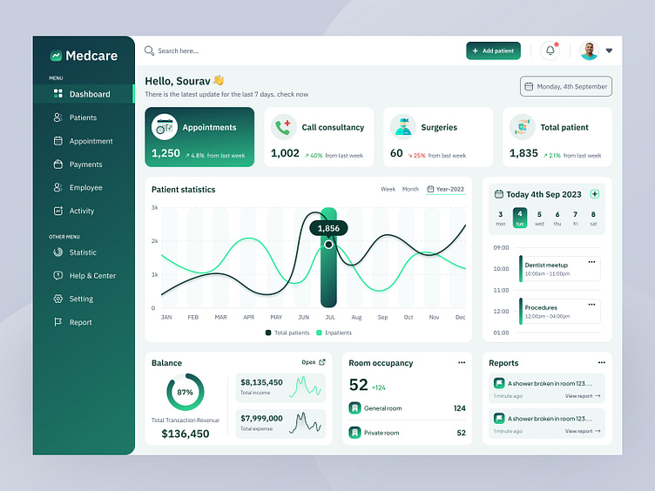
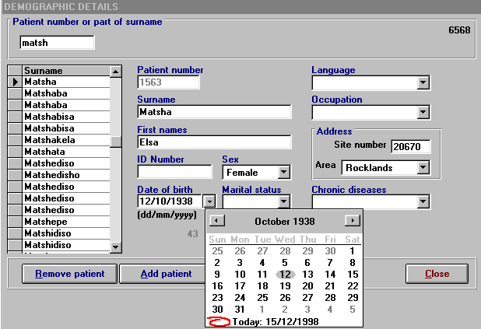
CityCare Hospital has:
- Online Appointment Booking
- Patient Registration System
- Electronic Medical Records (EMR)
- Billing & Insurance Processing
- Lab Report Portal
- Doctor Scheduling System
They recently migrated their application to cloud VMs and installed Dynatrace OneAgent for monitoring.
Management is facing issues:
- Slow appointment booking during peak hours
- Billing system timeout errors
- Database CPU spikes at night
- Occasional downtime in lab portal
Your act as Observability Engineers.

2. Technical Architecture (Lab Setup)
Application Flow
User → Nginx Web Server → App Service → Database
Example stack:
- Web Server: Nginx (Linux)
- Application: Node.js / Java / .NET Core
- Database: MySQL
- OS: Ubuntu Linux
- Monitoring: Dynatrace OneAgent (Full Stack mode)

3. Core Services to Monitor
Students must identify these in Dynatrace:
- Frontend Service – Patient Portal
- Appointment API
- Billing Service
- Lab Report Service
- Authentication Service
- MySQL Database
- Host metrics (CPU, Memory, Disk)

4. Simulated Problems for Practice
simulate issues:
Issue 1 – Slow Appointment Booking
Simulate:
- Add sleep delay in appointment API
- Or run CPU stress on server
Expected Dynatrace Observation:
- Increased response time
- Service flow shows delay in Appointment API
- PurePath traces show long method execution
- Smartscape highlights impacted services

Issue 2 – Database Bottleneck
Simulate:
- Heavy SELECT queries
- Run stress test on DB
Expected Monitoring:
- DB CPU spike
- Slow database statements
- Increased failure rate
- Service dependency map shows DB as root cause
Issue 3 – Billing Timeout
Simulate:
- Stop DB service temporarily
- Add connection pool limit
Expected Outcome:
- 500 errors in billing
- Failed service calls
- Root cause: DB unavailable
5. Tasks (Hands-On Labs)
Lab 1 – Verify OneAgent Installation
Students must:
- Check host in Dynatrace
- Validate processes detected
- Confirm services auto-detected
- Switch between Infrastructure & Services view
Deliverable:
- Screenshot of host CPU, memory
- List of detected services
Lab 2 – Smartscape & Topology Analysis
Students must:
- Open Smartscape
- Identify:
  - Frontend
  - Backend services
  - Database
- Draw dependency flow manually
Question:
If Database fails, which services are impacted?

Lab 3 – PurePath Deep Dive
- Trigger slow appointment booking
- Go to Distributed Traces
- Identify:
  - Slow method
  - Database call duration
  - External calls
Deliverable:
- Root cause explanation
Lab 4 – Create Hospital Monitoring Dashboard
Students must create dashboard with:
Tiles:
- Host CPU %
- Memory Usage
- Appointment API Response Time
- Billing Failure Rate
- Database Response Time
- Active Users
- Top 5 Slowest Services
- Service Flow visualization
6. Dashboard Design Example
Hospital Operations Dashboard
Sections:
Infrastructure Health
- Host CPU
- Host Memory
- Disk Usage
Application Health
- Response Time
- Throughput
- Failure Rate
Business KPIs
- Appointments per minute
- Billing transactions
- Active users

